**History Method**

History is a BOM method used to control on visited pages. We can do that by using history properties:

|  |  |
| --- | --- |
| **Property** | **Description** |
| history.back(); | This property is used to go back one step to the previous visited page in your browser. |
| history.forward(); | This property is used to go forward one step to the next visited page in your browser. |
| history.go(±num of page); | This property is used to go back or forward specific number of visited pages in your browser. |
| history.assign(“link”); | This property is used to open a new page. |
| history.replace(“link”); | This property is used to open a new page in place of another one. |
| history.reload(false | true); | This property is used to reload (ease refresh) the page from the cache of the browser instead of cache of the server. It accepts one parameter called “**force get**” this parameter may be **false (default)** or **true**.  **False** 🡺 to make “***easy refresh***” (refresh from the cache of the browser instead of cache of the server).  **True 🡺** to make “***hard refresh***” (refresh from the cache of the server instead of cache of the browser). |
|  |  |

**Note:**

1. By default all pages which you open will automatically save in history.
2. In case of replace property there is a new page open instead another one so the second will override the first, and the first will be deleted from the history.
3. You should learn cache.

**Example:** on back, forward, go properties.

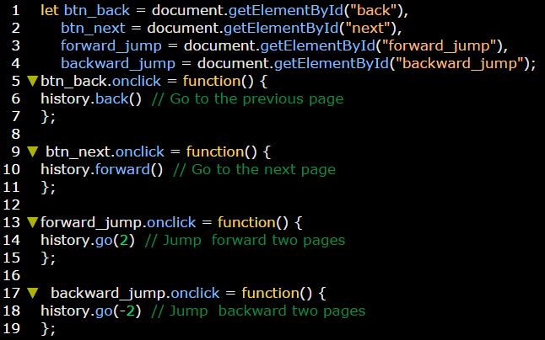

**Example:** on assign, replace, and reload properties.

